North Lincolnshire Council
Daily Event Analysis
6th December 2010

Overview

The Dawes Lane Coke Oven (DLCO) Osiris measured a daily mean PM₁₀ concentration of 82µg/m³ on Monday the 6th December 2010 exceeding the allowed 50µg/m³ as a daily mean. Concentrations of PM₁₀ were above the 50µg/m³ between 07:30 and 24:00. The Low Santon TEOM measured a daily mean concentration of 69µg/m³. Data was lost between 12:00 & 15:00 at the Low Santon TEOM due to an equipment audit by AEA Technology.

A check of the data has revealed elevated concentrations of PM₁₀ between 07:00 and 10:45 at both sites (circled in red). During this period the DLCO Osiris measured a mean concentration of 110µg/m³ and the Low Santon TEOM 122µg/m³.

Met Conditions

Consistent Southerly winds were recorded throughout the day. The wind within the 3 hour & 45 minute period of focus ranged between 144° and 233°. Wind speeds averaged at 1 m/s. Thick snow covered the ground.

Episode Wind Range
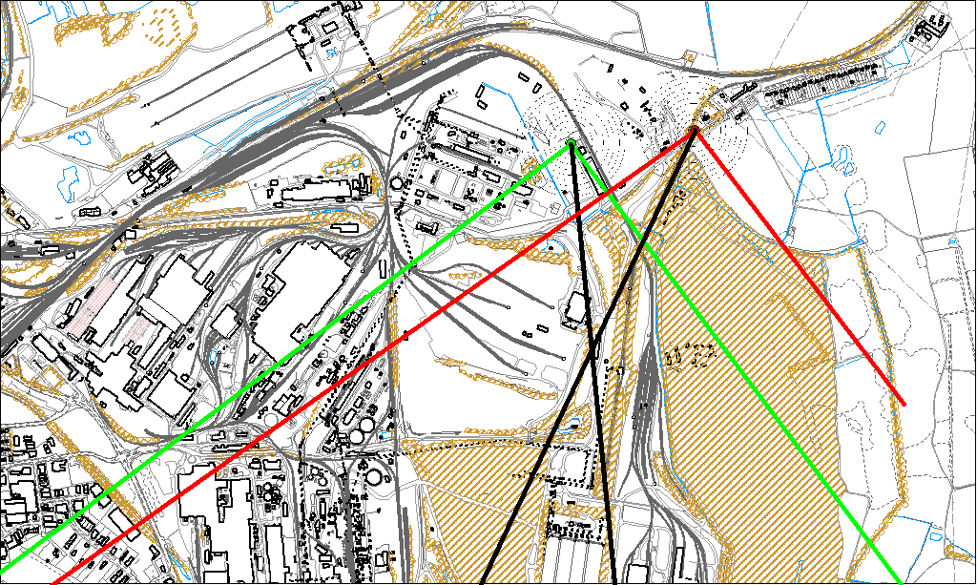

Potential Sources

The above map shows the Low Santon TEOM (indicated by the red lines) and the DLCO Osiris (indicated by the green). The black line within the red shows the wind direction of the highest concentration recorded during the 3 hour and 45 minute period of focus.

As both the Low Santon TEOM and the DLCO Osiris measured consistently higher concentrations during this period, it is likely that they were affected by a similar source. Therefore, the areas within both the red and green lines intersect are likely to be the location of the problem.

The likely areas include;

- Redbourn Site
- Slag Haul Road Entrance
- Intermediate Site
- Ore Beds
- Yarborough Site

